**Task 8: Working and understanding VPN**

**Deliverables:** Report describing VPN setup steps and connection status screenshot.

**Setup Steps:**

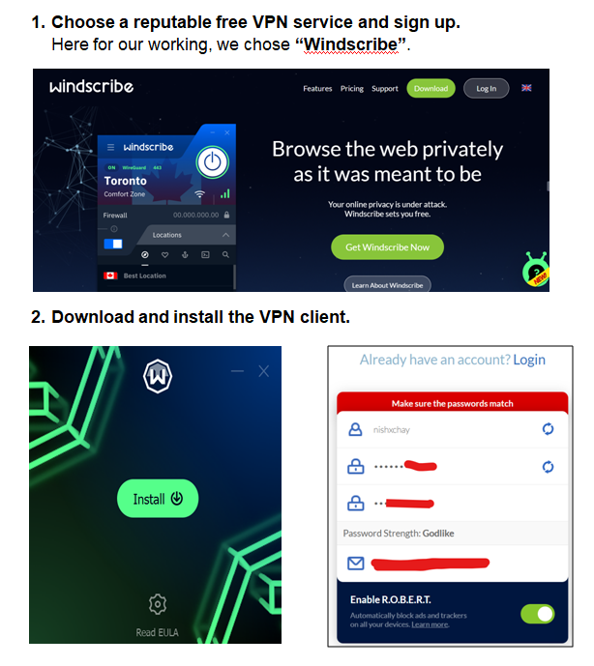

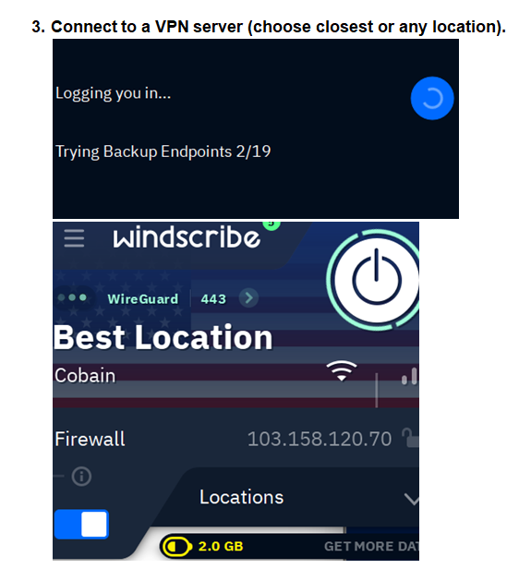

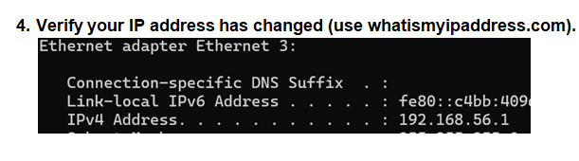Here, we chose UNITED STATES.

**Connection Status Screenshot:**

